Multi table incremental load or delta load from Azure SQL to adlsgen2(storage account).
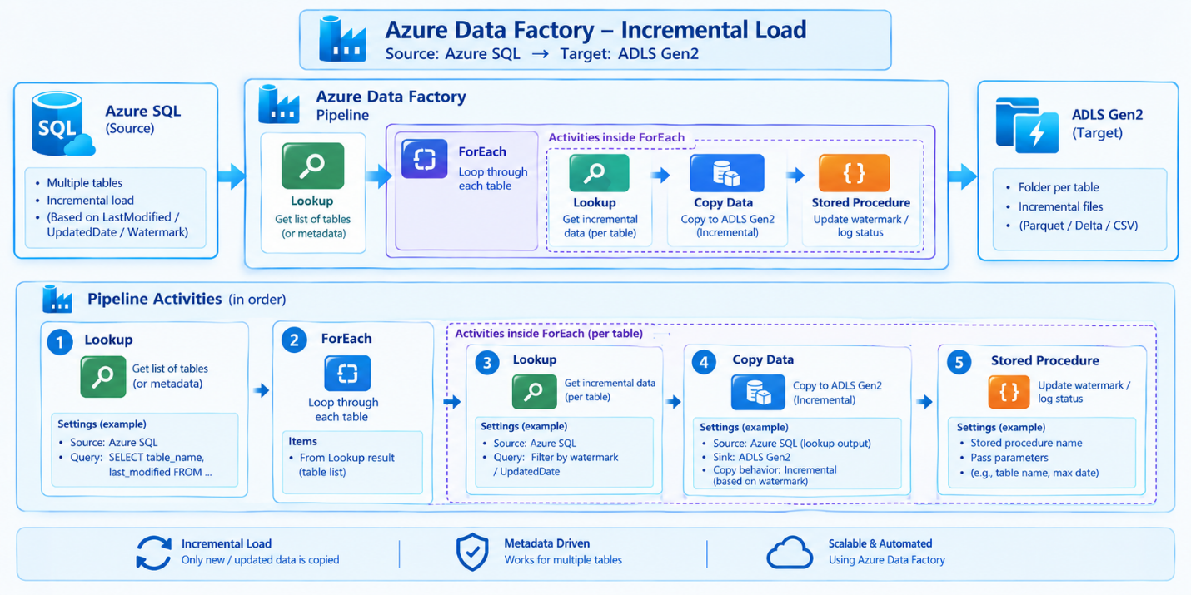

Condition: Either your tables have an id column or date time column
Logic: Source timestamp > last processed value in metadata
Step1: every table each time we need to get max timestamp
Step2: max timestamp we need to update in metadata table under last processed value column
Scenarios:
1. How to copy Multi tables from Azure SQL to adlsgen2 incrementally
2. How to maintain last processed values for each table
3. look up activity- value
4. foreach activity- iterate- item
5. copy activity – dataset parameters
6. Stored procedure activity
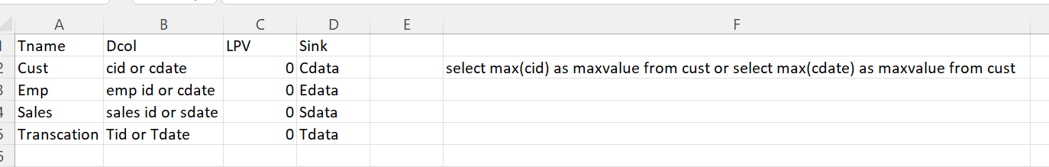
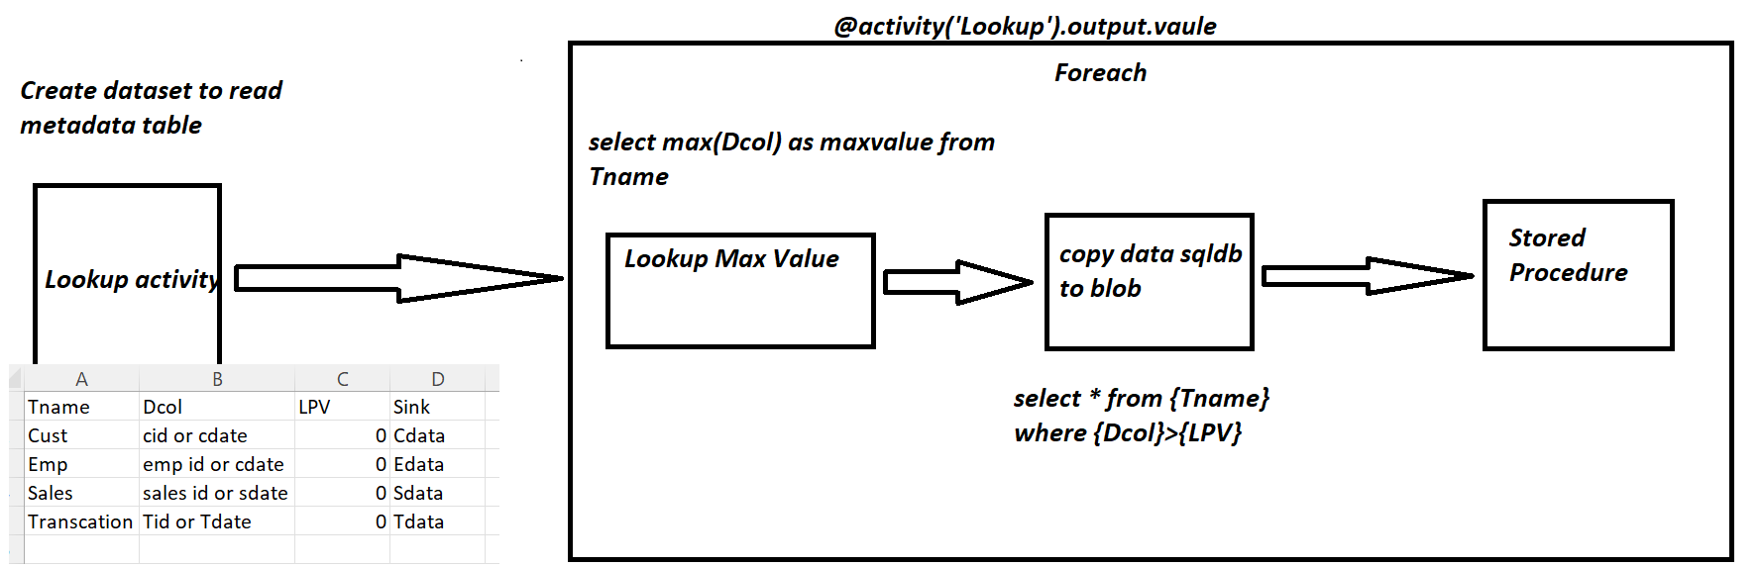
Imp points:
1. In ADF- there is a relationship b/w previous activity and coming activity
2. previous activity producing some output , that ouput help to the coming activity as a input
3. Look up activity always talk about "value" manner
4. foreach activity always talk about "item" manner
5. sql server point of view talk about "row" manner
6. Dataset parameters - For handling bulk of tables+ each and every table have the own schema name and table name as well as I want to maintain my own nameing convention, once the data is successfully
copied from azure sql to adlsgen2 under bronze container

7. Dont create dataset parameters for look up activity becoz purpose of lookup activity here to get only metadata information

- First lookup activity here we are taking about metadata, so uncheck the “First row only” option
- Inside foreach, lookup activity, make sure check the “First row only” option

Script:
create table emp(ename varchar(50),esalary int, empdate datetime)
create table cust(cname varchar(50), accounttype varchar(50), custdate datetime)
create table orders(productname varchar(50), quantity int, orderdate datetime)

INSERT INTO emp (ename, esalary, empdate) VALUES
('rama', 5000, '2023-01-01 10:10:10'),
('krishna', 2000, '2023-01-02 10:10:10'),
('sai', 3000, '2023-01-03 10:10:10');

insert into cust(cname,accounttype, custdate) values
('david','saving','2023-01-01 10:10:10'),
('michel','current','2023-01-11 10:10:10'),
('warner','saving','2023-01-02 10:10:10')

insert into orders(productname,quantity, orderdate) values('laptop',1,'2023-01-01 10:10:10'),
('mobile',1,'2023-01-10 10:10:10')

create table metadata(schemaname varchar(50), tablename varchar(50), deltacol varchar(50),
last_processed_value datetime, foldername varchar(50))

insert into metadata (schemaname,tablename,deltacol,last_processed_value, foldername)
values('dbo','emp', 'empdate','2023-01-01 09:10:10','empdata'),
('dbo','cust', 'custdate','2023-01-10 09:10:10','custdata'),
('dbo','orders', 'orderdate','2023-01-01 09:10:10','orderdata')

create proc metadata_usp @LPV datetime, @tablename varchar(50)
as
begin
update metadata set last_processed_value=@LPV where tablename=@tablename
end
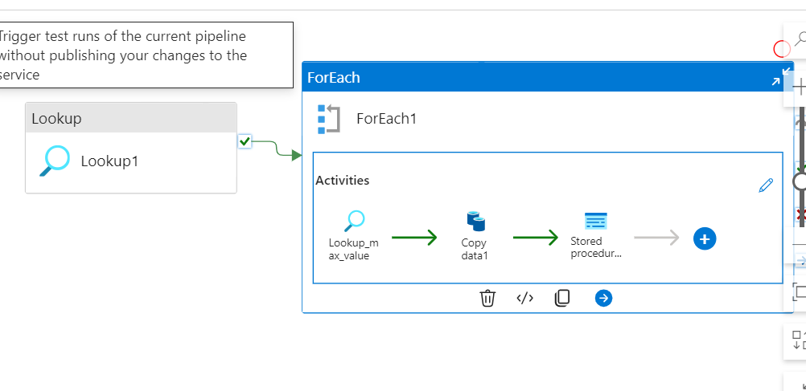
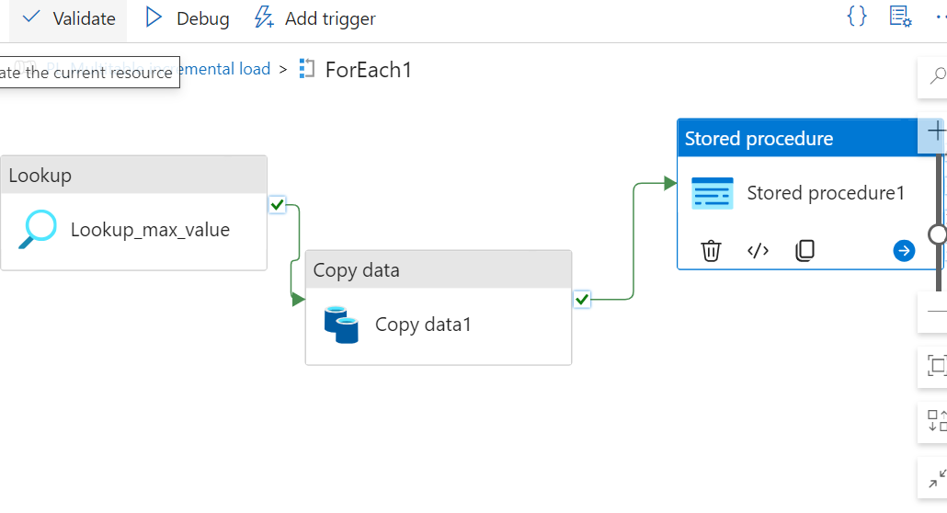

lookup_max_value activity query:
select max(@{item().deltacol}) as maxvalue from @{item().schemaname}.@{item().tablename}

Copy activity source query:
select * from @{item().schemaname}.@{item().tablename} where @{item().deltacol}>'@{item().last_processed_value}'

Stored procedure activity:
LPV parameter: @activity('Lookup_max_value').output.firstRow.maxvalue
Tablename: @item().tablename

